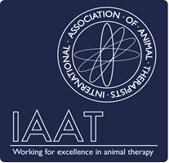
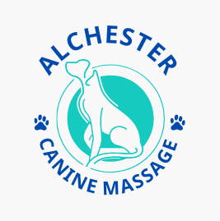
Veterinary Consent Form
Canine Massage Therapy

Michelle Pank, Alchester Canine Massage, T: 07738449128 E: Alchestermassage@gmail.com
Owners Name:
Home Address:

Postcode:
Phone Number:
Email:
Dog’s Details
Name | Gender | DOB
Neutered? | Breed

I declare I am the legal owner of the above named dog and that all information presented is correct to the best of my knowledge. I consent for my dog to be treated by Michelle Pank and understand that the consenting vet or surgery shall not be held responsible, nor liable for any aspect of the Canine Massage provided by the above named therapist.
I accept full responsibility for divulging facts that may be relevant during treatment, particularly regarding any changes in my animal’s health
Owner’s Signature: | Print Name: | Date:

To be completed by your vet including signature
Details of conditions requiring treatment and any specific instructions

Is the dog on medication? If yes, what?

Veterinary Surgeon’s Name | Practice Address/Practice Stamp
I confirm that the above-named dog has no contraindications to receiving canine massage and give consent to treatment

Signature of Veterinarian: Date:

Print Name:

I (Michelle Pank) acknowledge and respect the Veterinary Surgeons Act 1966 and Exemption Order 2015 by never working upon an animal without gaining prior veterinary consent.

